EAST LONDON RUNNERS – elrNEWSLETTER – December 2010

Season's Greetings!
Merry Chris tmas and a Happy New Year.
EAST LONDON RUNNERS sends Season's greetings to all Members, their partners, family and friends for a Merry Christmas and a happy, healthy and prosperous New Year 2011.

Target Races - Winter 2010/Spring 2011
Some favourite races in which members of East London Runners compete.
1. Sunday 2nd January 2011 - Ilford AC 10 mile Cross Country at Hainault Forest.There will be free festive refreshments at the Clubhouse afterwards. More details are available on the website at
www.ilfordathleticclub.co.uk
2. Sunday 16th January 2011 - Cross Country League Fixture at Watford.
3. Sunday 23rd January 2011 - Benfleet 15.
It has a challenging 15 mile, multi-terrain course, incorporating sections of the Canvey Island sea wall, and the undulating Hadleigh Downs, therefore it is not suitable for spikes.
www.benfleetrunningclub.com
4. Sunday 13th February 2010 - Cross Country League Fixture at Royston
5. Sunday 27th February 2011 - Roding Valley Half Marathon, Woodford Bridge
Now in its 29th year, the RVHM is a very popular and friendly race, also serving as a good warm up for those doing the London Marathon. It caters for a wide range of standards and abilities from experienced club runners to beginners.
www.rvhm.org.uk
6. Saturday 19th March 2011 - Orion 15, Epping Forest
Not only is there the breathtaking beauty of a Spring day in Epping
Forest,runners are overwhelmed by history. Queen Elizabeth's Hunting Lodge, built in 1543; the Obelisk marking the spot north of Greenwich used to establish the Meridian line; Dick Turpin's hide-out; the birthplace of Speedway racing in Britain; Lawrence of Arabia's fruit trees; an ex-Italian POW camp; olde worlde lovele pubbes........and lots of hills and mud.www.orionharriers.org.uk/fif15.htm
7. Sunday 20th March 2011 - Brentwood Half Marathon.
Entries are now open for the 2011 event. Please don't delay. Sold-out by December last year!www.brentwoodhalf.org
8. Sunday 17th April 2011 - Virgin London Marathon 2011.
www.virginlondonmarathon.com
Sunday Cross Country League - Race 3 Digswell - 12th December 2010
Results from the latest Cross Country race.
Andrew Baxter | 40:46 | 63rd
Derek Wright | 42:47 | 92nd
Rob Heppell | 44:47 | 116th
Jimmy Hartwell | 46:07 | 136th
Doug Mansell | 61:16 | 155th
Edward Barnard | 49:58 | 179th
Dave Knight | 51:06 | 192nd
Don Bennett | 60:10 | 246th
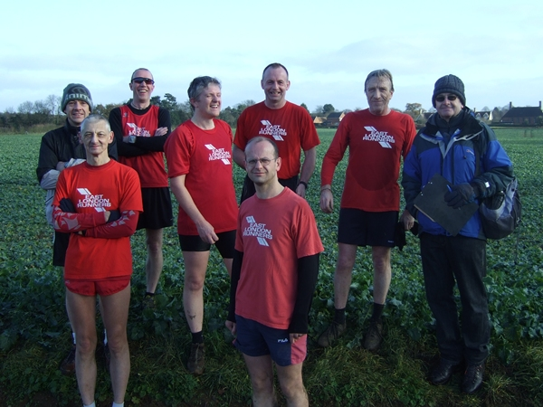
Back Row:Andrew Baxter, Rob Heppell, Edward Barnard, Jimmy Hartwell, Dave Knight, Frank Brownlie. Front Row: Doug Mansell, Derek Wright.
For the third race of this season's Sunday league, the club returned to Digswell, missing from the fixture list last year, but visited in 2008. Billed as 6.4 miles, but more like 5.7, the course consisted of two laps through farmland, generally flat for the first half of the lap, before the climb lovingly known as "Heartbreak Hill" which introduced a second half that was mainly downhill or flat. The lap was punctuated by three kissing gates that brought runners to a halt. While on the day there were no complaints about the weather, the snow a week earlier meant that it was hard work on the stretches on either side of the first kissing gate and before Heartbreak Hill - competitors ran to the side of and then across a field on a muddy surface and on a slope. Even those with studs struggled in these sticky conditions, while anyone still in road shoes was destined to be labelled reckless. Towards the end of the first lap, the field was long and slippery, while at the end of the second the race to the line was a welcome downhill on a country lane.
The men were out in force, fielding a full team of eight, and supported by chairman Frank, beverage technician Jaime and, at the top of the last downhill, Jim Bird. Our last runner was brought home by the ELR men's voice choir who gave a rousing rendition of "One Don Bennett". With ladies completely absent, the men joked that the number of ladies next month would be minus one. Or is that the expected temperature at Watford? Only time will tell.
Results - Essex Vets Cross Country Championships
Hainault Forest, Chigwell Row on Saturday 4th December 2010
Ladies V35: 59 finishers, winner 35:32
Kirsty Weston | 51:06 | 36th
Caroline Meaby | 51:45 | 38th
Rachel Coombs | 52:08 | 39th
Jayne Browne | 58:22 | 53rd
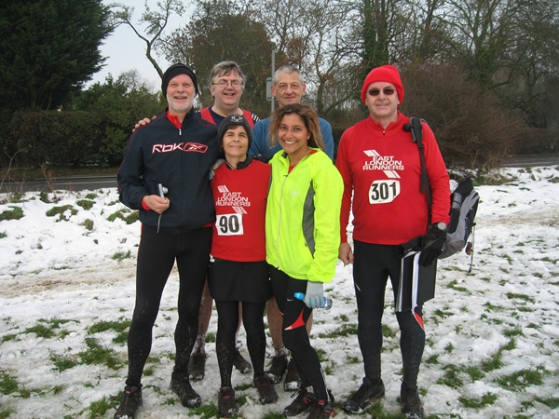
Men's V50: 87 finishers, winner 33:35
Mike Wilson | 45:52 | 53rd
Doug Mansell | 47:55 | 63rd
Frank Brownlie | 50:33 | 74th
John Atkinson | 51:50 | 77th
Don Bennett | 61:16 | 87th
Men's V40-50: 75 finishers, winner 33:11
Derek Wright | 40:03 | 40th
Richard Mainwaring | 44:55 | 61st
Grant Conway | 45:39 | 63rd
Jimmy Hartwell | 47:02 | 67th
Paul Thompson | 48:03 | 69th
Edward Barnard | 48:46 | 70th
George Georgiou | 49:42 | 71st
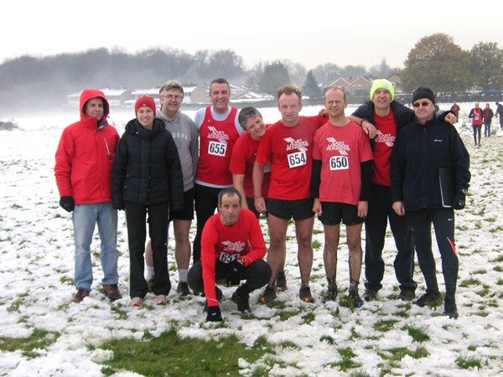
A mist hung over the snow covered fields at the start of this year's Essex Vets Cross Country Championships at Chigwell Row, well known to club members as the start of the Newman Hilly 5 and many a Sunday run. The event was divided into three categories, the ladies' V35, the men's V50 and the men's V40, the first two taking place in the same race at 11am, the last in a separate race at noon. The course was over a different section of Hainault Forest from the Hilly 5. Totally about 5.5 miles, it consisted of two laps of a circuit starting off with half a lap round a field followed by an uphill section into the forest, a long downhill section and then a return journey uphill again. All familiar territory to Sunday runners. The sight of Jim Bird towards the end of the lap marked the end of the uphill stretch, at least until the next lap! After a snowy week, the temperature was above zero and the thaw in progress meant the ground was either slushy or muddy all the way. Studs were de rigueur and soon the backs of our legs were caked with mud. This was cross country of the old school, negotiating narrow forest paths, leaping over logs or ducking under branches. In spite of the bleak weather halving the turnout, ELR were well represented, Kirsty, Mick and Derek leading their respective categories to the finish. Jaime Towns was on hand once again to take photographs.
Weekend runs - January 2011
Proposed runs for the New Year
Sunday 2nd January 2011 - Ilford AC 10 mile Cross Country at Hainault Forest at 11am. Entries on the day, by 10.30am, £7 for ELR members.In conjunction with the race will be a Mob Match (10 members per club to score – mixed, prizes to the winning team)
Saturday 8th January 2011 - Essex Senior Cross Country Championships at Hadleigh, Essex at 1.30pm for Ladies (5 miles) and 2pm (7.5miles) for men.
Sunday 9th January 201 1 - Forest run at 9.30am from Hainault Forest, Hilly 5 Car park, for 10 miles.
Saturday 15th January 2011 - Road run at 9.00am from Wanstead Leisure Centre, up to 12 miles.
Sunday 16th January 2011 - Cross Country League Fixture at Watford.
Sunday 23rd January 2011 - Benfleet 15 race.
www.benfleetrunningclub.com
Sunday 30th January 2011 - Up to 15 mile Canal run.
Race Reports
Recent races completed by members of East London Runners
Bedford Half Marathon - Sunday 12th December 2010
Grant Conway 1:47:43pb
Sarah Burns 2:07:34
Grant's race report. The Bedford half was a tough race over scenic
undulating country roads which started at Wootton in Bedfordshire and took you
through Buckinghamshire as well on a tour of local villages and back to Wootton.
The race was well organised with car parking being provided.......Click here to read rest of the report.
Angkor Wat, Cambodia - Half Marathon - Sunday 5th December 2010.
Avoiding the snow and the UK's sub-zero temperatures, ELR member Tom Woods competed in the Angkor Wat Half Marathon in Cambodia on Sunday 5th December 2010. Around 700 runners from all over the world took part , mainly volunteers/relief/charity organisations.
The race started at 06:30am , which is very late for running events in this part of the world , reason being there is no electricity to illuminate the course , hence have to wait till sun-up.The course was flat all the way , very scenic and passed through all the ancient ruins of this UNESCO world heritage site , but as the race progressed so the sun began to rise higher in the sky and the temperature rose to over 30C , really draining me especially over 18km to 21km. I finished on rubbery legs in 2hrs 15mins 13secs. Next race for me will be my first full marathon in Khon Kaen, Thailand on Sunday 23rd January 2011.
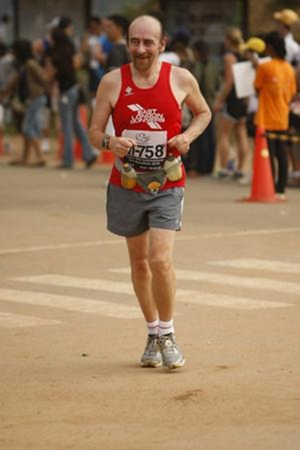
Tom Woods in ELR colours in Cambodia
Tip of the Month
Running in cold weather
It is recommended to have two different types of training regimes, a summer and a winter training programme. Runners should not plan to make any increases in mileage or add speed work to the training regime in the winter. Cold and Icy conditions can provide an ideal scenario to slipping and injuring a muscle or even breaking a bone. It is advisable to warm up indoors before you commence running and be especially vigilant if conditions are icy or wet. Try not to run on icy roads and opt for snow as this surface will provide better traction. It is also advisable to shorten your running stride and run slightly slower.
Clothes
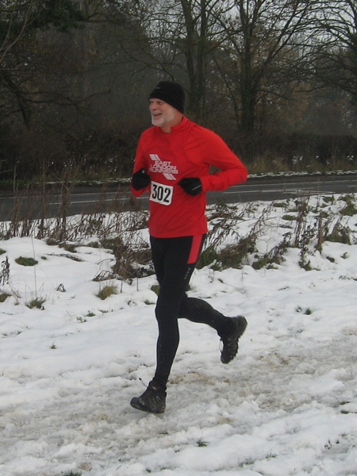
ELR's John Atkinson wearing appropriate clothing for winter running
Runners mu st wear appropriate clothing for running in cold conditions. Wear thick absorbent dry socks and make sure you have adequate space in your running shoes to accommodate these thicker socks. Some runners actually buy a Â½ size larger running shoe for winter training to accommodate for thicker socks. Taking care of your feet is essential on order to prevent frostbite and circulatory problems with the feet. Try to wear a warm hat when you are running in cold conditions.
A significant amount of body heat is lost from the head which affects the whole body's circulation. Wool gloves and thick running track suits are also recommended. If it is not very cold then you may wear a layer of polypropylene shirt below a sweat shirt, that should be enough for the upper body.
Some runners prefer to wear polypropylene or Lycra shorts together with wool running trousers. Underwear is also an important item and often overlooked, opt for insulated underwear with a special attention to the front panel being insulated to prevent a cold related injury.
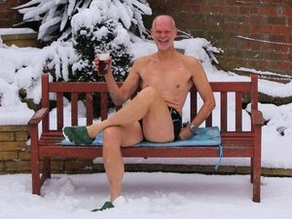
ELR's John Atkinson shows how not to dress in cold weather!
Wind Chill
The weatherman's favourite word are, the wind chill factor�. Runners must be careful with running into a wind-chill as the extreme cold can be draining and even dangerous. Some runners prefer to run into the wind to start off with and then return with the wind at their backs. The return run is easier as you have perspired and your body is warmer.
Skin care and Hydration
Make sure you use a moisturizer and sun block to prevent blister formation and redness in the face area. It is imperative that you remember to maintain adequate hydration before and after running to ensure your muscles recover after running in cold weather.
If you decide to run in cold weather then take it easy. Studies have shown that long, intense activity such as running can make you susceptible to colds. Try and drink a high carbohydrate energy drinks on the run, it will help maintain your immune system. Eating fresh vegetables and taking vitamin C can also help prevent a cold while running in cold conditions.
Runners Shorts!
by Long Legs
Congratulations to ELR member David Da Silva Pereira and Anne-Claire Marsaud on their recent engagement.
Almost 40 East London Runners attended the Annual Christmas meal on Wednesday 15th December 2010. Held at 9pm in The George, Wanstead following the weekly club run.
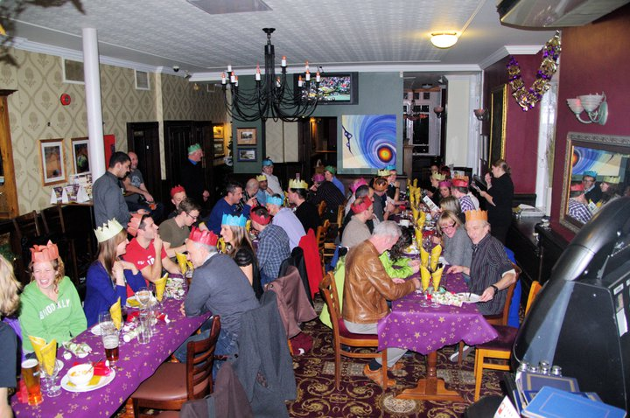
Well done to those ELR members who successfully gained a place in the Virgin London Marathon 2011 in the Club's annual ballot.
Sarah Merrick, Mike Wilson, Tara Syed, Natalie Dale, Karen Levison, Frank Brownlie, Andrea Middleton, Tom Lawrence, Julie Onwukegu.
Charity Quiz - Virgin London Marathon fundraising.
ELR member Jayne Browne and work colleague Sam Dyer are holding a Charity Quiz night on Friday 28th January 2011.Venue – Counting House, 50 Cornhill London EC3V 3PD,(upstairs room with own bar and cloakroom). Time – 18.30 till late. Cost - £10 per head (this includes buffet food and the Quiz).Teams will comprise of 5 to 6 people.Contact Jayne via our webmaster e.mail address if you would like to participate.
If you have a story that you would like to share with your fel low East London Runners, or should you wish to have your personal race reviews published, please contact us via the webmaster email link here:
webmaster@eastlondonrunners.org.uk

Visit our website at www.eastlondonrunners.org.uk or our Facebook page

